Homework 1
1.
- Determine whether each silicon diode in Figure 1 is forward-biased or reverse-biased.
- Determine the voltage across each diode in Figure 1, assuming the practical model.
- Determine the voltage across each diode in Figure 1, assuming an ideal diode.
- Determine the voltage across each diode in Figure 1, using the complete diode model with r’_{d} = 10 Ω and r’_{R} = 100 MΩ.
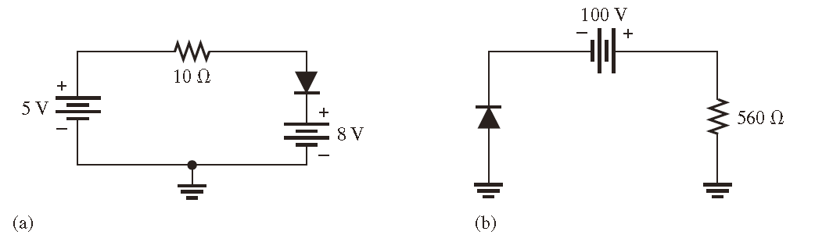
Figure. 1

2.
(1) Draw the output voltage waveform for each circuit in Figure 2 and include the voltage values (diode is ideal).
(2) What is the peak inverse voltage across each diode in Figure 2 (diode is ideal).
(3) What is the peak forward current through each diode in Figure 2 (diode is ideal).
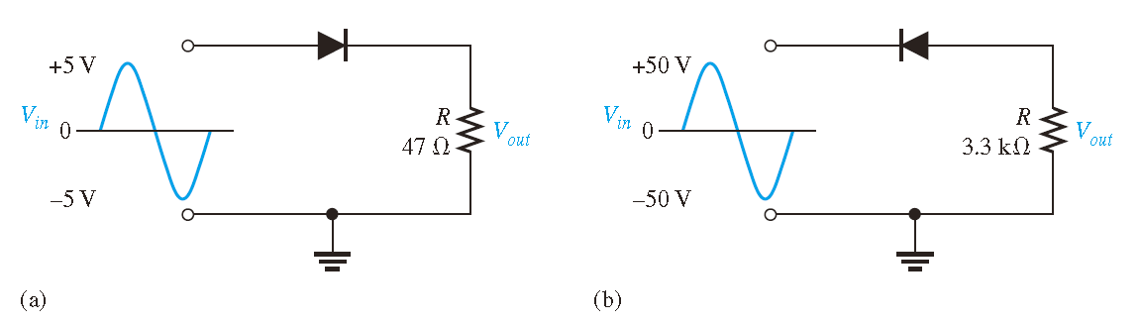
Figure. 2

3.
(1) Determine the peak and average voltage delivered to R_{L} in Figure 3 for both ideal diode and non-ideal diode.
(2) Determine the peak and average power delivered to R_{L} in Figure 3 for both ideal diode and non-ideal diode.
.

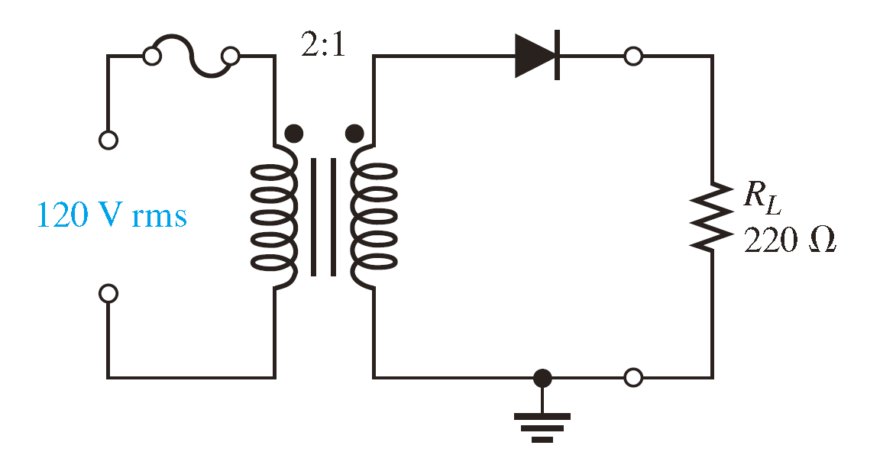
Figure. 3

4. Consider the circuit in Figure 4 (diode is non-ideal)
(a) What type of circuit is this?
(b) What is the total peak secondary voltage?
(c) Find the peak voltage across each half of the secondary.
(d) Sketch the voltage waveform across RL.
(e) What is the peak current through each diode?
(f) What is the PIV for each diode?

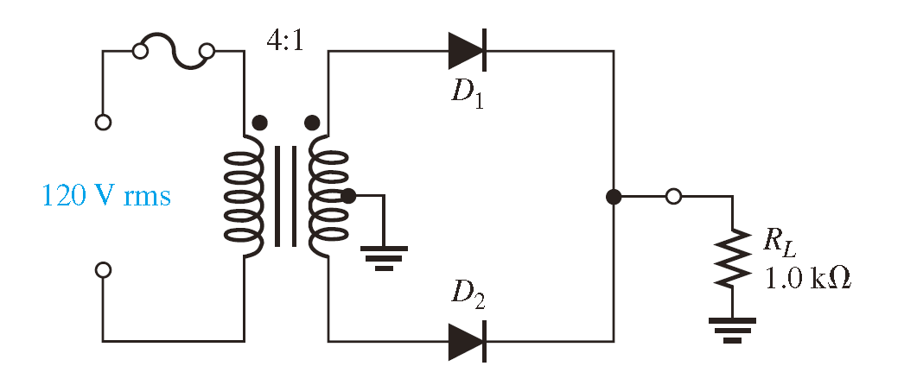
Figure. 4

5. Draw the output voltage waveform for the bridge rectifier in Figure 5 for both ideal diode and non-ideal diode cases.
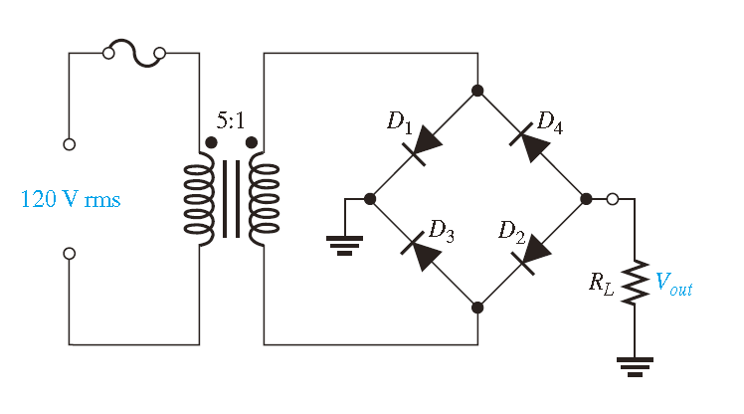
Figure. 5

